All below scenarios have transaction entered by Bank Employees who know the service terms for Account Maintenance and Loans.

Scenario 1: Withdraw $100 with Transaction Fees $10 from Savings account# AS00000007 for customer# C000000005

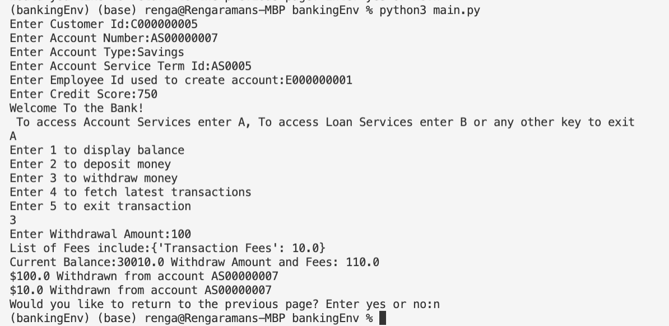

Scenario 2: Create a new Checking Account # AS00000007 and Deposit $10000 for Customer# C000000007. Then view the current balance for the customer

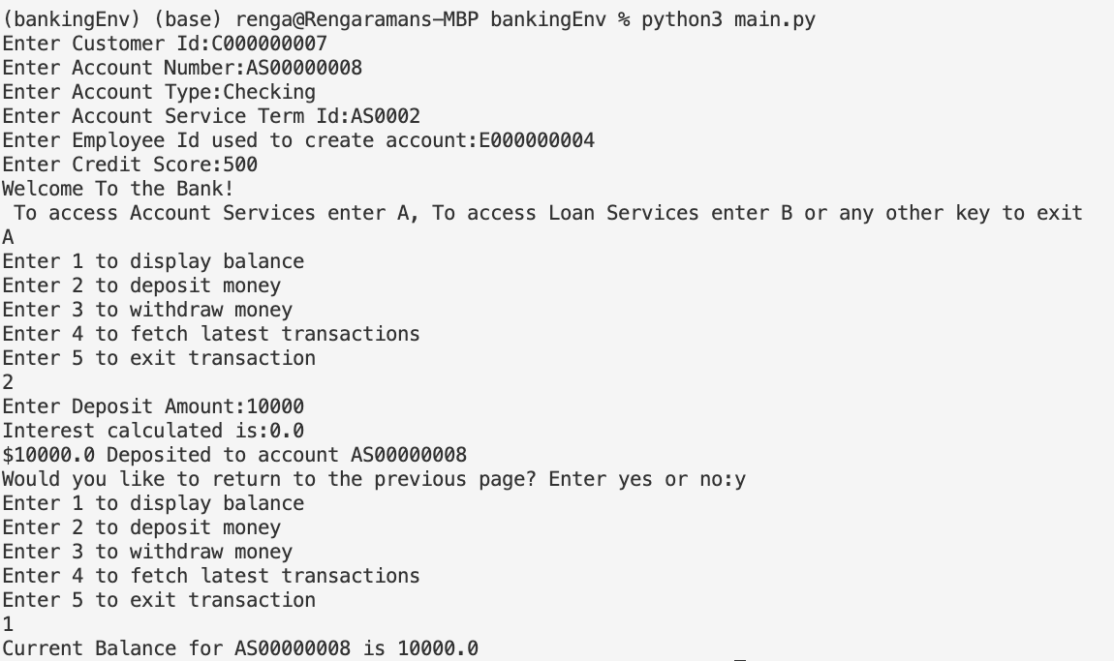

Scenario 3: Create a new Home Loan Account# LS00000003 for customer# C000000007

Amount of Loan with Loan cost = $81600

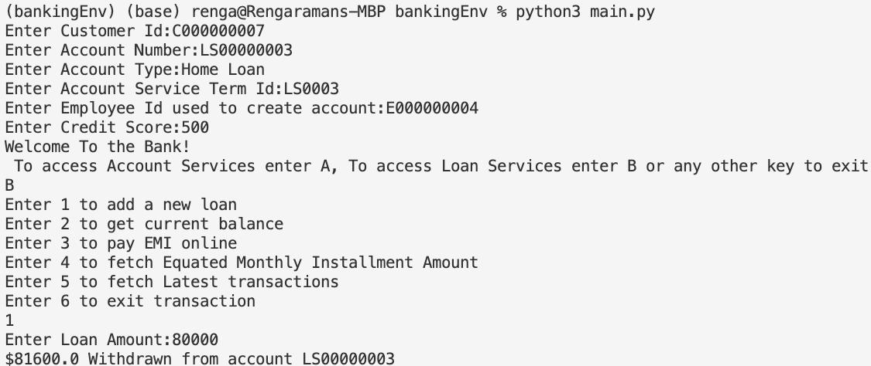

Scenario 4: Fetch current balance followed by EMI amount split by Principal and Interest for Loan account# LS00000003 for customer# C000000007

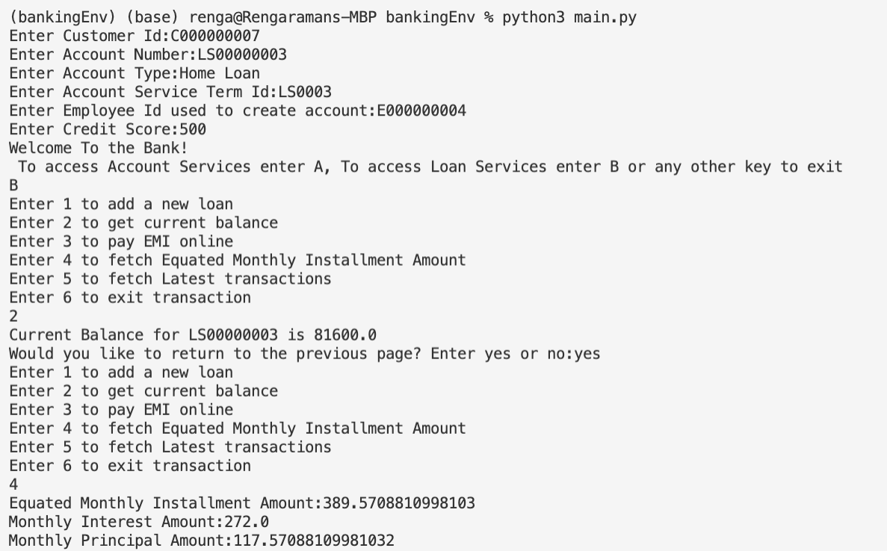

Scenario 5: Pay Little more than the EMI Amount to get additional amount added to principal and display the last few transactions corresponding to Loan account# LS00000003 for customer# C000000007

